## 🩺 Project Report: Blood Pressure Stage Prediction System

### 📌 1. Project Title

**Blood Pressure Stage Classification using Machine Learning**

### 🎯 2. Objective

To develop an intelligent web-based system that predicts a person's blood pressure stage (e.g., Normal, Elevated, Stage 1, Stage 2) based on health-related input features using machine learning techniques.

### 📋 3. Tools & Technologies Used

* **Languages:** Python, HTML, CSS
* **Libraries:** Pandas, NumPy, Scikit-learn, Matplotlib, Seaborn, Flask, Pickle
* **ML Models:** Logistic Regression, Decision Tree, Random Forest, K-Nearest Neighbors, Support Vector Machine
* **Framework:** Flask (for web app)
* **IDE:** VS Code / Jupyter Notebook
* **Version Control:** Git & GitHub

### 🧠 4. Machine Learning Workflow

* **Data Source:**patient_data.csv and sample_blood_pressure_data.csv
* **Preprocessing:**
  + Cleaning stage labels (e.g., fixing typos like Stage_1 vs Stage 1)
  + Encoding categorical variables using LabelEncoder
* **Model Training:**
  + Multiple models tested
  + Accuracy comparison across models
  + Best-performing model selected and saved using joblib/pickle
* **Output:**model.pkl, label_encoders.pkl

### 🧪 5. Model Performance

Accuracy results of various classifiers:

|  |  |
| --- | --- |
| **Classifier** | **Accuracy (%)** |
| Logistic Regression | XX.X |
| Decision Tree | XX.X |
| Random Forest | **YY.Y** |
| K-Nearest Neighbors | XX.X |
| SVM | XX.X |

*(Note: Replace XX.X and YY.Y with actual values from blood_pressure_analysis.py output)*

### 🌐 6. Web Application Components

Built using **Flask** to provide an interactive interface for users to predict BP stages.

#### HTML Files:

* **index.html**: Homepage with navigation to prediction form and details
* **prediction.html**: Input form where users enter their health data (age, cholesterol, heart rate, etc.)
* **details.html**: About page describing how the model works and how data is used

#### Backend:

* **app.py**:
  + Loads model.pkl and label_encoders.pkl
  + Accepts user input from prediction.html
  + Predicts BP stage and displays it on screen

📁 **7. Project Structure**

**├── app.py**

**├── blood_pressure_analysis.py**

**├── analyze_dataset.py**

**├── sample_dataset_structure.py**

**├── patient_data.csv**

**├── sample_blood_pressure_data.csv**

**├── model.pkl**

**├── label_encoders.pkl**

**├── templates/**

**│ ├── index.html**

**│ ├── prediction.html**

**│ └── details.html**

**├── static/**

**│ └── style.css (if applicable)**

**├── README.md**

**├── requirements.txt**

**└── screenshots/ (output visuals, accuracy chart)**

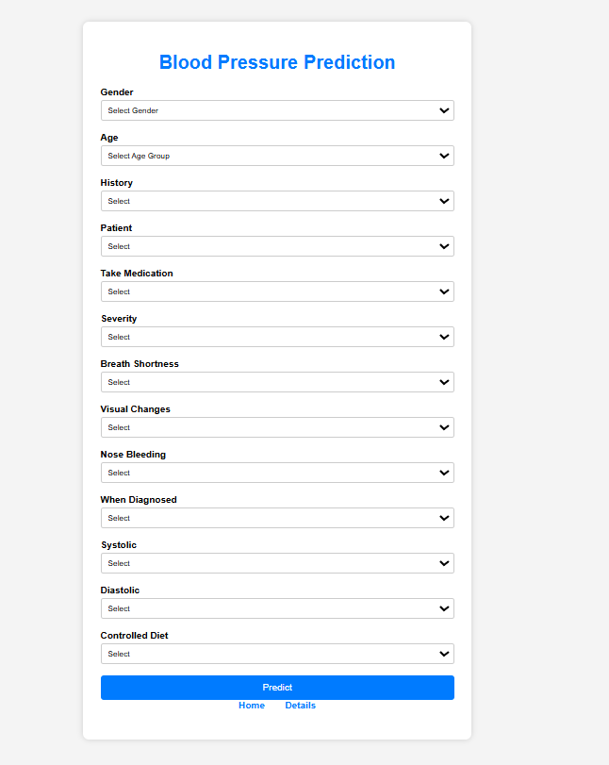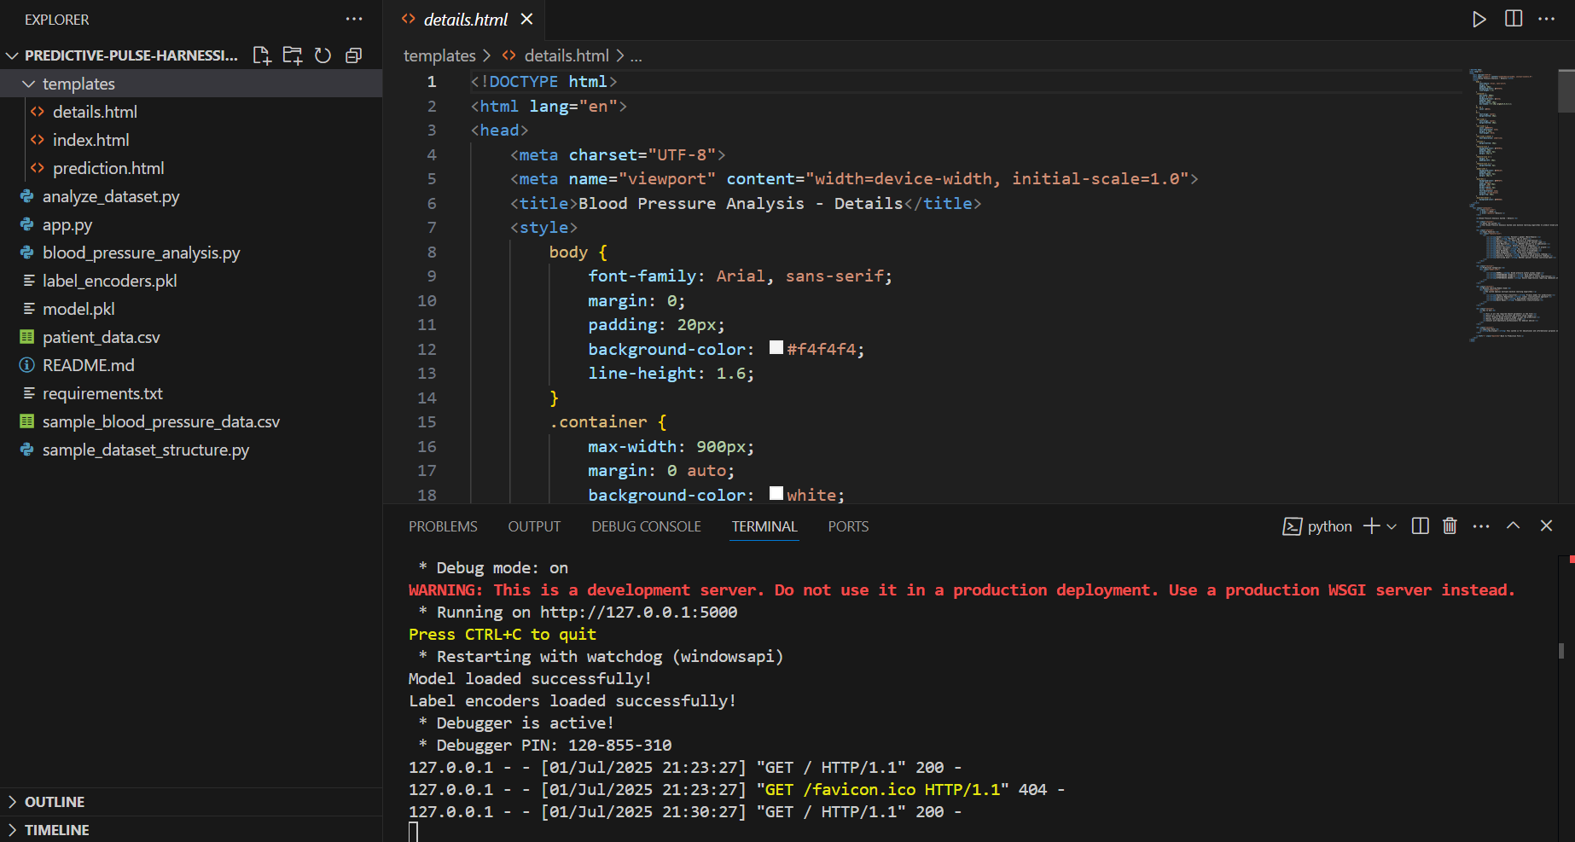

📸 8. Screenshots

* Accuracy Comparison Plot
* Model Prediction Result Page
* Input Form Screenshot

*(Include these in the screenshots folder in GitHub)*

### 🎥 9. Project Demonstration Video

Include:

* Brief intro to the project
* Dataset preview
* Model training demo
* Web interface walkthrough
* Live prediction demo

### 🔗 10. GitHub Repository

https://github.com/Technophile-1/Predictive-Pulse-Harnessing-Machine-Learning-for-Blood-Pressure-Analysis.git

### ✅ 11. Project Status

* ☐ Data Analysis and Cleaning
* ☐ Model Training and Saving
* ☐ Web Application Setup
* ☐ Frontend Integration with Flask
* ☐ Documentation & Report
* ☐ Mentor Review & Approval